Project Planning Phase

Project Planning Template (Product Backlog, Sprint Planning, Stories, Story points)

| **Field** | **Details** |
| --- | --- |
| **Date** | 26 JUNE 2025 |
| **Team ID** | LTVIP2025TMID43759 |
| **Project Name** | Hematovision: Blood Cell Classification Using Transfer Learning |
| **Team Leader** | Nuthakki Sreekar Ranga Rao Chowdary |
| **Team Members** | Lasa Sravani, M Althaf Vali, M Lavanya |

# Project Overview

Hematovision is a web-based application designed to classify microscopic blood cell images using deep learning and transfer learning techniques. It provides an intuitive interface for users to upload images and instantly receive the type of white blood cell (e.g., neutrophil, monocyte) predicted by the model. This tool helps support early medical diagnosis and enhances the understanding of blood cell morphology.

# Product Backlog, Sprint Schedule, and Estimation

|  |  |  |  |  |  |  |
| --- | --- | --- | --- | --- | --- | --- |
| Sprint | Functional Requirement (Epic) | User Story No. | User Story / Task | Story Points | Priority | Team Members |
| Sprint-1 | Data Collection | USN-1 | Collect and load microscopic blood cell images | 5 | High | Sreekar, Lavanya |
| Sprint-1 | Data Preprocessing | USN-2 | Resize, normalize images and balance the dataset | 4 | Medium | Althaf, Sravani |
| Sprint-2 | Model Building | USN-3 | Build and train transfer learning model | 5 | High | Sreekar, Althaf, Sravani |
| Sprint-2 | Cell Type Prediction | USN-4 | Predict blood cell type from an uploaded image | 5 | High | Sreekar, Lavanya, Sravani |
| Sprint-3 | UI Design | USN-5 | Design a web UI to upload blood cell images and view prediction | 3 | Medium | Sreekar, Lavanya |
| Sprint-3 | Model Integration | USN-6 | Integrate trained model into the web interface | 3 | Medium | Althaf, Sravani |
| Sprint-3 | Deployment | USN-7 | Deploy the full application on a web server | 3 | Medium | Sreekar, Althaf, Lavanya |

# Project Tracker, Velocity & Burndown Chart

|  |  |  |  |  |  |  |
| --- | --- | --- | --- | --- | --- | --- |
| Sprint | Total Story Points | Duration | Sprint Start | Sprint End | Points Completed | Release Date |
| Sprint-1 | 20 | 6 Days | 18 June 2025 | 20 June 2025 | 20 | 20 June 2025 |
| Sprint-2 | 20 | 6 Days | 20 June 2025 | 22 June 2025 | 18 | 22 June 2025 |
| Sprint-3 | 20 | 6 Days | 23 June 2025 | 25 June 2025 | 19 | 25 June 2025 |

# Velocity Calculations

- Total Story Points: 57

- Total Sprints: 3

- Velocity = 57 / 3 = 19 story points per sprint

- Total Duration: 6 days

- Average Velocity = 57 / 6 = 9.5 story points per day

# Burndown Chart Description

The burndown chart illustrates:

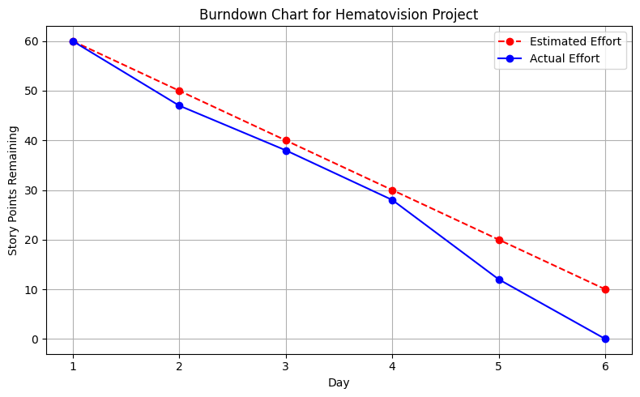

Useful for tracking day-to-day sprint performance and task completion.